HyGen Life Considerations

Bill Marty, Kurt Armbruster  
May 24, 2016

Useful lifetime of HyGen are an important consideration for our customers and for us as business. This memorandum explores the known data behind our life predictions for both battery and engine life and what our options are.

## Battery Life - Background

With HyGen running a typical 2.5 Kilowatts load for a telecommunications tower, the engine will be on for approximately 1.35 hours (81 minutes) and off for 2.3 hours (138 minutes) for a total cycle time of 3.6 hours. When the engine is off, the load will run off the batteries. Assuming the load stays constant the generator system will go through an average of 6.6 cycles per day or 2,400 cycles per year. The range of all HyGen performance is summarized in Table 1 and Chart 1 below.

Lithium Ion batteries as used by HyGen have a significantly longer life than traditional lead-acid batteries. Their longer cycle life is a key advantage in using Li-ion in high cycle applications. Conversely if the use is only for backup with infrequent use, lead-acid batteries are a better economic choice.

Depending on depth of discharge and operating temperature, a typical sealed lead-acid batteries provides 200 to 400 charge/discharge cycles. The primary reason for this relatively short cycle life is chemical in nature and results in corrosion of the positive electrode, depletion of the active material and expansion of the positive plates.

Lithium Ion batteries have much better lifetimes as well as much better specific energy, i.e. more energy per volume. Lifetimes range from 1,000 to 10,000 cycles although their lifetimes depend on a number of factors.

Factor 1 – Depth of Discharge:  
All batteries are at their worst when they are charged all the way to maximum and then depleted all the way to minimum. Most Li-Ion batteries are used over a range of 80% Depth of Discharge (DOD). For example a cell phone battery is used over an 80% range i.e. even when the display says “100%” that is typically about 90% of chemical energy and when it says “0%” that represents about 10% of the chemical energy.

Manufacturers typically quote performance numbers for 80% DOD. These are supported by test data. In HyGen we use a 50% DOD specifically to extend the life of the batteries. Cycle life at a 50% DOD is better and longer but they are not as well documented by performance estimates and test data.

**Table 1: Expected HyGen Performance**

|  |  |  |  |  |  |
| --- | --- | --- | --- | --- | --- |
| Power Draw (watts) | Engine  On (Hrs) | Engine Off (Hrs) | Cycle Time (Hrs) | Cycles per day | Cycles per Year |
| 500 | 0.92 | 11.5 | 12.4 | 1.93 | 706 |
| 1,000 | 1.00 | 5.7 | 6.7 | 3.56 | 1,299 |
| 1,500 | 1.09 | 3.8 | 4.9 | 4.88 | 1,780 |
| 2,000 | 1.21 | 2.9 | 4.1 | 5.88 | 2,148 |
| 2,500 | 1.35 | 2.3 | 3.6 | 6.58 | 2,403 |
| 3,000 | 1.53 | 1.9 | 3.4 | 6.97 | 2,546 |
| 3,500 | 1.76 | 1.6 | 3.4 | 7.06 | 2,576 |
| 4,000 | 2.08 | 1.4 | 3.5 | 6.83 | 2,494 |
| 4,500 | 2.53 | 1.3 | 3.8 | 6.30 | 2,299 |
| 5,000 | 3.25 | 1.1 | 4.4 | 5.46 | 1,991 |
| 5,500 | 4.53 | 1.0 | 5.6 | 4.30 | 1,571 |
| 6,000 | 7.48 | 1.0 | 8.4 | 2.85 | 1,039 |

**Chart 1: Expected HyGen Performance**



**Assumptions used in Table 1 and Chart 1**

Engine Power = 7.5 kW

Alt. Efficiency = 95% DC-DC Efficiency = 95%

Battery Pwr (each) = 1.1 kW-Hr Number of Batteries = 11

Depth of Discharge = 50% Energy per charge = 6.05 kW-Hr

Factor 2 – Capacity  
As batteries age, they lose capacity. To use the convenient example of a cell phone, when new a cell phone runs 10 hours between charges, when old it only runs 8 hours between charges. This is an example of an 80 % end-of-life capacity. This is also the point that most manufacturers document as the end of life point. However as users of older cell phone know, they continue to degrade and can still be used.

Battery manufacturers typically quote lifetimes as the number of cycles before they reach an 80% capacity. With HyGen we can easily accommodate batteries less than 80%. The unit will naturally adapt and have shorter times for both charge and discharge. While we can easily accommodate degradation up to 50% we have defined 70% as a useful life of HyGen.

Factor 3 – C Rate  
C-Rate is the “Charge” or discharge rate of the battery. It is essentially how fast the energy is being transferred into or out of the battery. The faster a battery is charged and discharged the worse it is on lifetimes. In other words trickle charging is much better than fast charging for all batteries.

For best battery life, the C-rate should be below 1.0 and preferably in the range of .50. Most of the HyGen’s cycles fall in this region.

## Battery Life - Data

In the following analysis and performance graphs we looked at four estimates: for the service life of Beckett battery modules used in HyGen.

Case 1: The most conservative, it is based on Beckett’s specification for their modules, 3,000 cycles at 80% depth of discharge and 0.5C charge rate. End of Life (EOL) for the battery is defined when battery capacity has fallen to 80% of original capacity.

Case 2: This represents the initial engineering estimate of 7500 cycles, achieved by limiting DOD to 50%, still using a 0.5C charge rate and 80% EOL. The 7500 cycle number is a “guesstimate” made by Michael Holder (7000) and Bill Marty (7500).

Case 3: Boston Power. Beckett does not specify, or have data on the cycle life of their modules at 50% DOD. The individual cells are made by Boston Power (Swing® 5300 ) and they provided an estimate of 10,000 cycles at 50% DOD and 25C operation. This still assumes an 80% EOL Capacity.

Case 4: Extrapolation. The final curve is an extrapolation of Boston Power’s 10,000 cycles if we run to 70% EOL. The engineering team has estimated that the batteries will continue to degrade and can reach a total of 15,000 cycles if a reduced EOL is defined as 70%.

**Chart 2: Expected HyGen Battery Life**

|  |  |  |  |  |
| --- | --- | --- | --- | --- |
| **Battery Parameters** | **(1)** | **(2)** | **(3)** | **(4)** |
| Beckett energy, kWh | 1 | 1 | 1 | 1.1 |
| Stack height | 11 | 11 | 11 | 11 |
| Batt bank energy, kWh | 11 | 11 | 11 | 12.1 |
| End of life definition | 80% | 80% | 80% | 70% |
| Avg bank energy over life | 90% | 90% | 90% | 85% |
| Depth of Discharge, % | 80% | 50% | 50% | 50% |
| Cycle energy, kWh | 7.92 | 4.95 | 4.95 | 5.14 |
| Batt Cycles, est | 3,000 | 7,500 | 10,000 | 15,000 |

This table shows the variables and assumptions that produced the curves above.

Beige highlighted cells show where the assumptions changed or differ.

**Chart 3 Boston Power Life Test Data (at 50% DOD)**

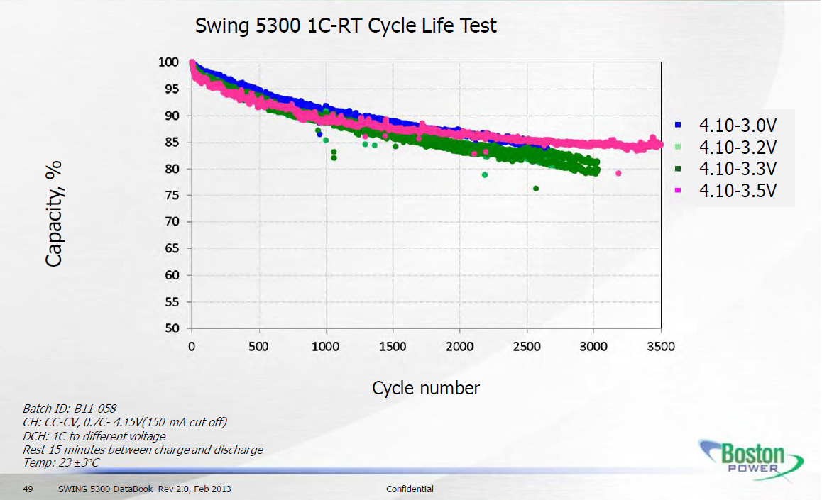

**Chart 4: Planetary Power’s Curve Fit of Boston Power data**



**Chart 5: Extrapolation of Battery Life Test Data for HyGen case**



## Battery Life Conclusions:

Providing exact battery life estimates is a hard thing to do. If we quote the Beckett specification sheet it only provides us a life of 3,000 cycles or an effective HyGen life of 1.6 years[1]. It is a small consolation to say that this does not represent our use case (80% DOD vs 50%). Clearly this is too conservative.

Boston Power has acknowledged the more benign conditions of operating at 50% DOD, and has estimated 10,000 cycles before reaching an 80% capacity at end-of-life. This translates to a HyGen Life of about 3.1 years. This is better but defines at EOL condition that is more severe than is reasonable for our expected usage.   
(Bill we need to confirm this data with Beckett and Boston Power in some way).

Finally our extrapolation of the end-of-life to 70% is easy to accommodate in HyGen performance. Looking at the data on the extrapolated graph it appears that we are making a reasonable assumption. However we cannot say with certainty that this will come true because it is a best estimate. Neither we, Beckett, nor Boston Power have test data in this regime. Data would also be very valuable to publish and share with potential customers, especially to share with technical buyers who are keen to this aspect.

Design Options: We could get to 5 year life by increasing the energy storage of our battery, thus reducing the number of battery cycles. This option is not cheap as it would double the number of batteries and thus double the cost (as well as add a slightly larger enclosure). Batteries would need to be doubled (going from 11 to 22) as it requires a full battery stack (11 batteries) to reach 300 volts operating voltage (Hi-buss voltage).

## Options:

1. Go Forward with HyGen as designed  
   Pros:
   1. Fastest path to market

Risks:

* 1. May be hard to convince customers of battery performance
  2. May need to warranty batteries for 4 or 5 years.  
     or may need to replace batteries after 2-3 years.
  3. Redesign product after a year of testing and field experience.

1. Design HyGen with 22 batteries  
   Pros:
   1. Highest performing unit
   2. Can adds a second BMS, which gives us better fault tolerance

Risks:

* 1. Highest cost unit. BOM goes up by approximately $8,000.   
     Unit Price goes up by aprox $12,000
  2. Need to add 3 months to schedule

## Engine Life - Background

Diesel engines also have a life. Perkins specifies the engine to have a 15,000 hour service life at our load of 70% of total rating. At that point they require a major overhaul or replacement. (An engine overhaul must be done in a shop and cannot reasonably be expected to be done on-site). As an aside, there are nearly 9,000 hours in a year, which is why non-hybrid generators tend to have around a 2 year service life.

Because the engine in HyGen cycles on and off, our service life is considerably longer than 2 years. At the low power the engine is not used much and life if not an issue. At the higher power, the engine runs more than 50% of the time and we do face engine life considerations.

These are plotted below in Chart 6 (Engine Life).

People in our industry tell us that the Perkins spec of 15,000 hours is pretty conservative. So we also looked at longer life numbers, this is shown in the lighter blue lines.

**Chart 6: Engine Life Considerations**

1. Note that operating HyGen at 80% DOD stretches the cycle times and results in fewer cycles per year than our current 50% DOD.